/*

program name:resturant bill

*/

#include<stdio.h>

int main()

{

int choice,quantity,total;

total=0;

printf("\n---- Veg khanna resturant menu-----\n");

printf("1.iddli Rs25\n");

printf("2.Dosa Rs50\n");

printf("3.Vada Rs20\n");

printf("4.upma Rs25\n");

printf("Which item to order(1-4)");

scanf("%d",&choice);

printf("How many plates:");

scanf("%d",&quantity);

switch (choice)

{

case 1:total=quantity*25;

break;

case 2:total=quantity*20;

break;

case 3:total=quantity*20;

break;

case 4:total=quantity*25;

break;

default:printf("Invalid choice!please select (1-4),\n");

}

printf("Total bill amount is:%d\n",total);

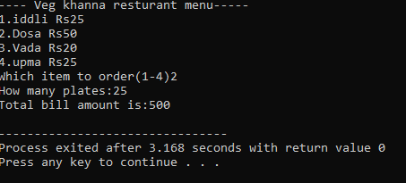return 0;

}

**Output:**